**1] Define OS. List out any 2 examples.**

**Operating System** lies in the category of system software. It basically manages all the resources of the computer.

A program that acts as an intermediary between a user of a computer and the computer hardware.

The operating system is designed in such a way that it can manage the overall resources and operations of the computer.

Examples

* Microsoft Windows.
* Mac OS.
* Android OS.
* Linux.
* Ubuntu.
* Chrome OS.
* Fedora.

2] List out goals of an OS.

* Execute user programs and make solving user problems easier.
* Make the computer system convenient to use.
* Use the computer hardware in an efficient manner.
* To hide the details of the hardware resources from the users.
* To manage the resources of a computer system.
* To execute and provide services for applications software.

3] Explain comp sys components with prop diag.

1. Hardware – provides basic computing resources (CPU, memory, I/O devices).

2. Operating system – controls and coordinates the use of the hardware among the various application programs for the various users.

3. Applications programs – define the ways in which the system resources are used to solve the computing problems of the users (compilers, database systems, video games, business programs).

4. Users (people, machines, other computers).

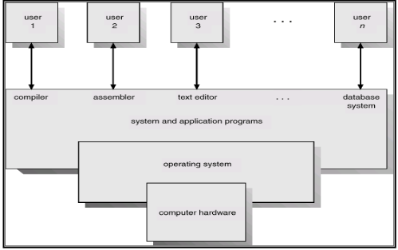

4] Explain diff services of an OS.

* Memory Management
* Device Management
* Processor Management
* Security
* Error detecting aids
* Coordination between other software and users
* Job accounting
* File Management

Memory Management

* Keeps tracks of primary memory, i.e., what part of it are in use by whom, what part are not in use.
* Allocates the memory when a process requests it to do so.
* De-allocates the memory when a process no longer needs it or has been terminated.

Processor Management

* Keeps tracks of processor and status of process. The program responsible for this task is known as traffic controller
* Allocates the processor (CPU) to a process.
* De-allocates processor when a process is no longer required.

Device Management

* Keeps tracks of all devices. The program responsible for this task is known as the I/O controller.
* Decides which process gets the device when and for how much time.
* Allocates the device in the most efficient way.
* De-allocates devices.

File Management

* Keeps track of information, location, uses, status etc. The collective facilities are often known as file system.
* Decides who gets the resources.
* Allocates the resources.
* De-allocates the resources.

Security: -

* By means of password and similar other techniques, it prevents unauthorized access to programs and data.

Job accounting: -

* Keeping track of time and resources used by various jobs and users.

Error detecting aids: -

Production of dumps, traces, error messages, and other debugging and error detecting aids.

Coordination between other software and users: -

Coordination and assignment of compilers, interpreters, assemblers and other software to the various users of the computer systems.

5] Enlist the types of an OS.

* Batch Operating System
* Multiprogramming operating system
* Time-sharing Operating Systems
* Distributed Operating System
* Real-Time Operating System

6] Explain multi-programming OS

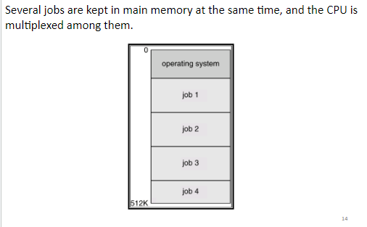

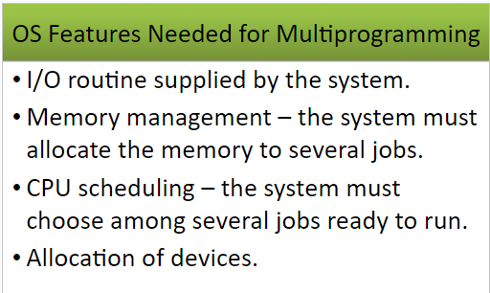

On a single processor computer, a multiprogramming OS can run many programs. In a multiprogramming OS, if one program must wait for an input/output transfer, the other programmes are ready to use the CPU. As a result, different jobs may have to split CPU time. However, their jobs are not scheduled to be completed at the same time

7] Explain Batch-OS.

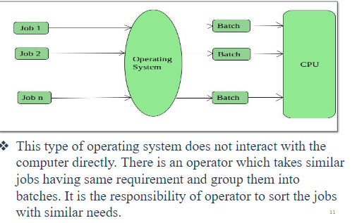

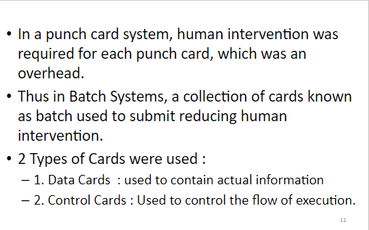

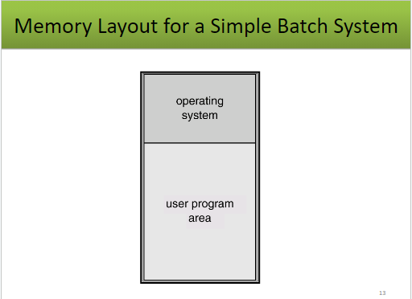

8] Write about distributed os.

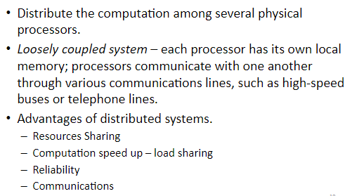

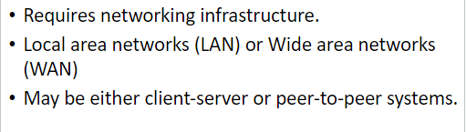

Applications of Distributed Operating System

The applications of distributed OS are as follows −

* Internet Technology
* Distributed databases System
* Air Traffic Control System
* Airline reservation Control systems
* Peep-to-peer networks system
* Telecommunication networks

9] Write a note on real time os.

RTOSes are designed to handle multiple processes at one time, ensuring that these processes respond to events within a predictable time limit.

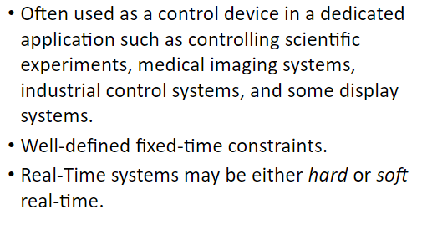

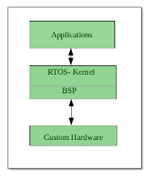

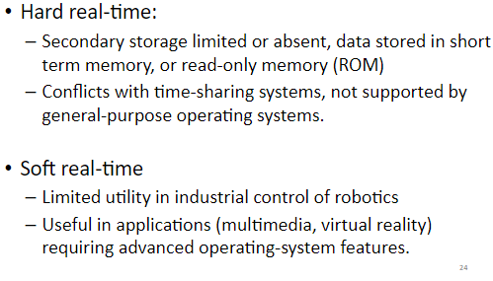

Examples

* air traffic control systems;
* anti-lock brakes and air bags;
* cameras;
* medical systems; and
* PCs.

10] Difference between CLI and GUI.

